**CS 6314.0U2 – Practice Work -2**

**Due date:** June 7, 2017, 10pm

Create below web page and layout by using Bootstrap. You can use cities text for different city descriptions.

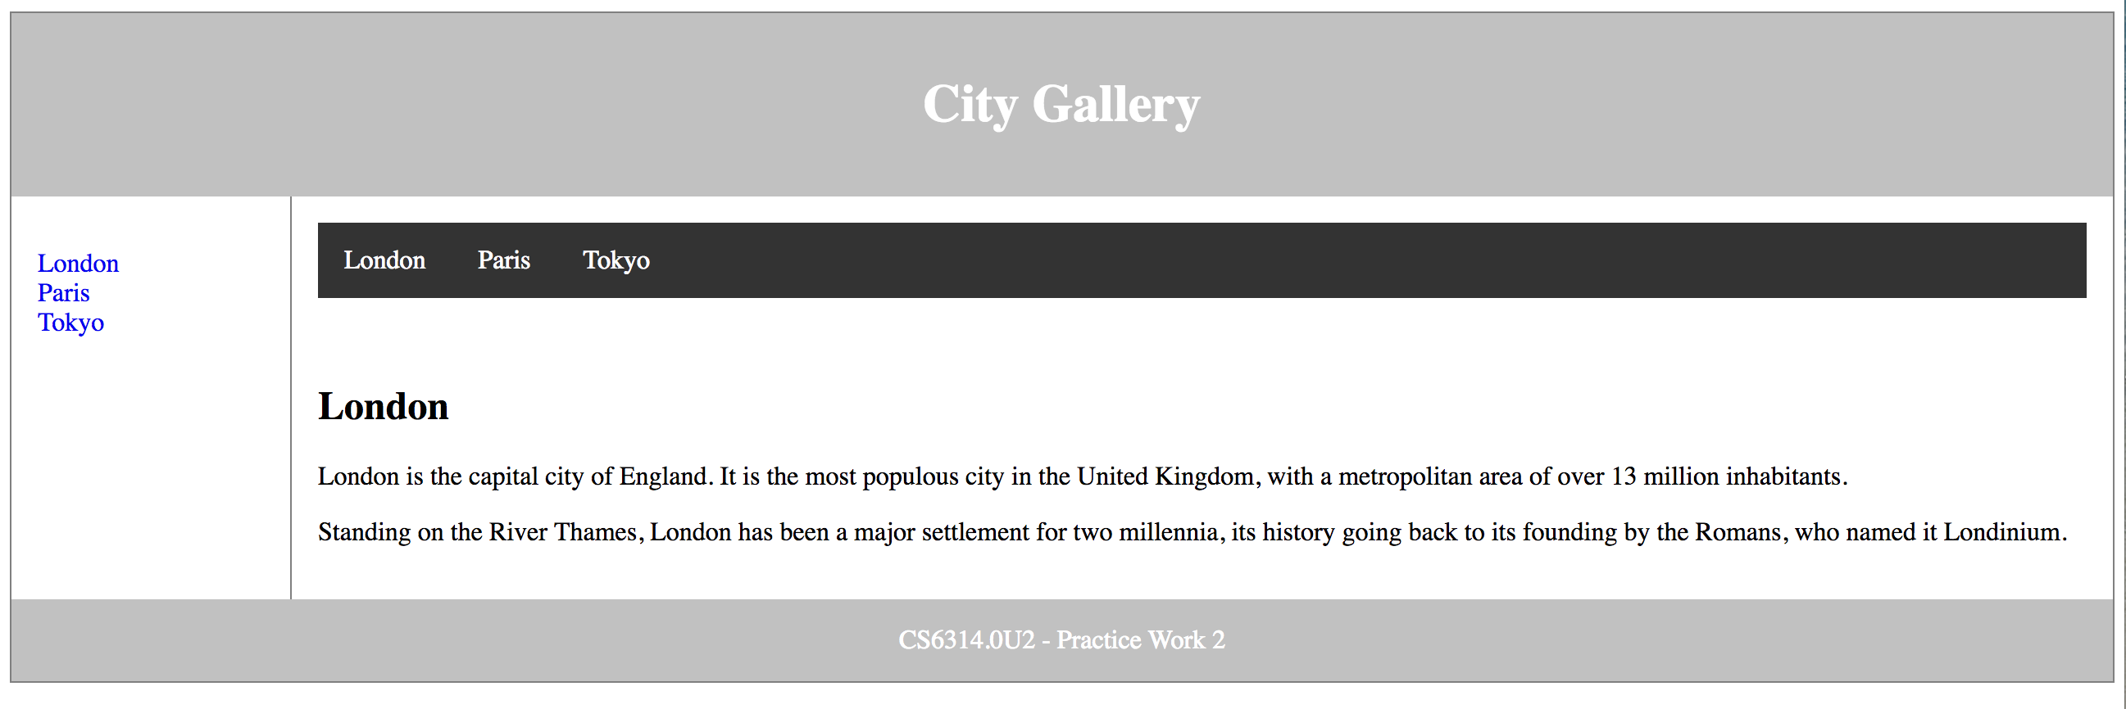

**Cities:**

**London**

London is the capital city of England. It is the most populous city in the United Kingdom, with a metropolitan area of over 13 million inhabitants. Standing on the River Thames, London has been a major settlement for two millennia, its history going back to its founding by the Romans, who named it Londinium.

**Paris**

Paris is the capital and the most populous city of France. It was founded in the 3rd century BC by a Celtic people called the Parisii, who gave the city its name. By the 12th century, Paris was the largest city in the western world, a prosperous trading center, and the home of the University of Paris, one of the oldest universities in history. In the 18th century, it was the center stage of the French Revolution, and was an important center of finance, commerce, fashion, science, and the arts, a position it still retains today.

**Tokyo**

Tokyo, officially Tokyo is one of the 47 prefectures of Japan, and is both the capital and most populous city of Japan. The Greater Tokyo Area is the most populous metropolitan area in the world.